6 VOCABULARY expressions with take
a) Look at three sentences from the lesson. What do the highlighted phrases with take mean? Which one is a phrasal verb?
Do you normally take out insurance when you travel? It's sensation-seeking, it's taking risks ... ... we need to take the risks involved in driving very seriously
b) Match some more expressions and phrasal verbs with take to their meanings.
Expressions with take

1 take care of
2 take advantage of
3 take part in
4 take place
5 take (your) time
6 take into account
Phrasal verbs with take
7 take after
8 take off
9 take up

A D look after
B D begin a new activity
C D participate in
D D happen
E D 1 (for planes) leave the ground; 2 (for clothes) remove
F D do sth slowly, not in a hurry
G D be similar to sb
H D make use of an opportunity
I D think about sb / sth when you are making a decision
c) Complete the questions with a phrasal verb or expression from (b).
1 Who do you take __________________ more, your father or your mother?
2 Do you worry about your health? Do you take________________________ yourself?
3 Do you get up very quickly in the morning or do you take ____________________ ?
4 Have you ever not taken _______________________a good opportunity (and regretted it)?
5 Have you ever taken ______________________________a demonstration?
6 Have you taken __________________________ a new sport or hobby recently?
7 Has any big sporting event ever taken ___________________ your (nearest big) city?
8 If you were thinking of buying a new computer or mobile phone, what factors would you take __________________?

Ссылка на quizlet для отработки https://quizlet.com/_88c6i0?x=1jqt

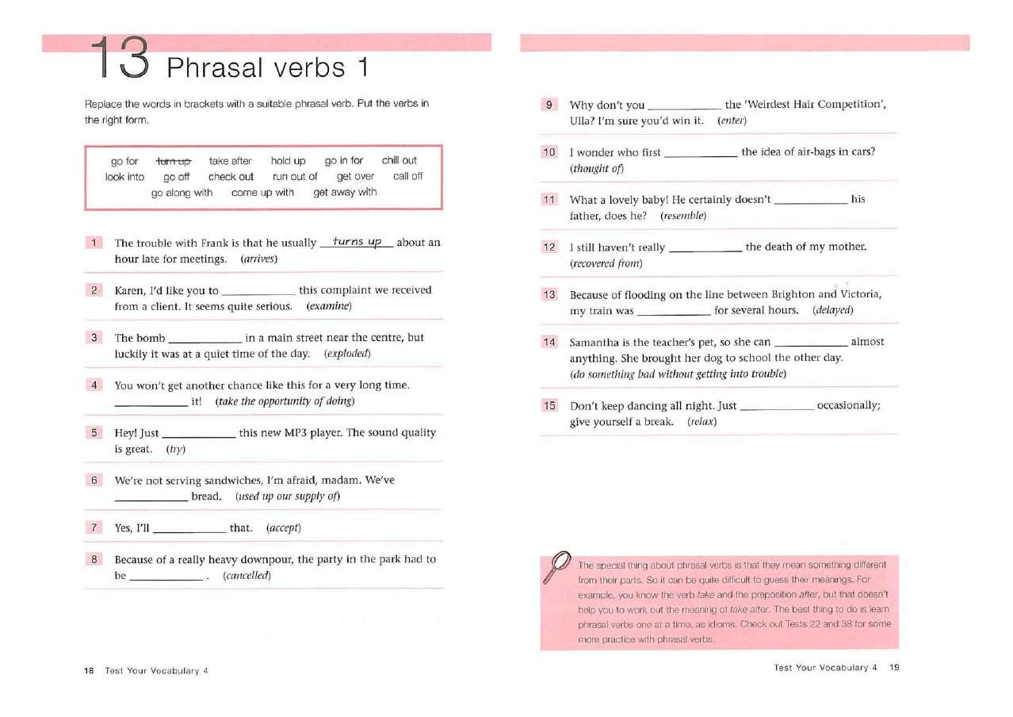

Прочитайте текст и выполните задания 1 – 7, выбирая букву A, B, C или D. Установите соответствие номера задания выбранному вами варианту ответа.
The introduction to a new biography of Gannibal by the author
Alexander Pushkin was not only Russia’s greatest poet, but he was also the great-grandson of an African slave. The slave, whose godfather was Peter the Great, claimed to have royal blood of his own. Certainly his Russian descendants ¹ believed that he was an African prince. His descendants have included members as well as close friends of the English royal family. So the legend goes on.
Pushkin told the story of his black ancestor ² in “The Negro of Peter the Great”, but this biography tells a different version. The main difference is between fact and fiction. The Russian poet hoped to discover a biographical truth by sticking to the facts, only to discover that facts are slippery ³ and not always true. His biography turned into ⁴ a novel. Even then, it was left unfinished after six and a half chapters. The scrawled manuscript comes to an end ⁵ with a line of dialogue – ‘Sit down, you scoundrel ⁶, let’s talk!’ — and a line of dots. Pushkin could be speaking to himself. In any case, it’s now time to stand up and carry on with the story. I have tried to join up ⁷ the dots.
This is a book, then, about a missing link between the storyteller and his subject, an African prince; between the various branches of a family and its roots; between Pushkin and Africa; Africa and Europe; Europe and Russia; black and white. It is the story of a remarkable life and it poses the question: how is such a life to be explained?
My own explanation began in 2001, while I was living in Russia and working there as a journalist. The first draft was written during the war in Afghanistan, on the road to Kabul, but it describes my journey to the frontline of a different kind of war in Africa between the armies of Ethiopia and Eritrea. According to legend, Pushkin’s ancestor was born there, on the northern bank of the River Mareb, where I was arrested for taking photographs and compass readings, on suspicion of being a spy. Understandably my captors ⁸ didn’t believe that I was only a journalist researching the life of Russia’s greatest writer. At the military camp, where I was held for a number of hours, the commandant looked me up and down ⁹ when I asked, in my best posh English accent, ‘I say, my good man, can you tell me, basically, what is going on here?’ ‘Basically,’ he replied, with distaste, ‘you are in prison!’ The incident taught me something. Journalists, like biographers, are meant to respect facts, and by retracing Gannibal’s footsteps, I hoped to find a true story.
Some of those journeys lie behind the book, and are used whenever it is helpful to show that the past often retains ¹⁰ a physical presence for the biographer – in landscapes, buildings, portraits, and above all ¹¹ in the trace of handwriting on original letters or journals. But my own journeys are not the point of the book. It is Gannibal’s story. I am only following him.
Descriptions of Africa and the slave trade result from my journeys, but this is not a book about a ‘stolen legacy’, nor certainly about the intellectual wars that have been part of black history in recent years. Biographers, like novelists, should tell stories. I have tried to do this. I should, however, point out ¹² from the outset that Gannibal was not the only black face to be seen in the centre of fashionable St Petersburg at that time. Negro slaves were a common sight in the grand salons of Millionaires’ Street and they appeared in a variety of roles, such as pets, pages, footmen, mascots, mistresses, favourites and adopted children. At the Winter Palace, so-called court Arabs, usually Ethiopians dressed in turbans and baggy trousers stood guard like stage extras in the marble ¹³ wings.
Соотнесите слова, выделенные жирным курсивом, и их значения:
- polished stone material used for building and sculpture/ adj. ___________________
- especially/ id. _______________________
- people that hold smb. captive/ noun _______________________
- to indicate or specify/ phr.verb __________________________
- a member of previous generations of one`s family/ noun __________________________
- to contain/ verb _______________________
- to become/ phr.verb _____________________________
- a villain/ noun ______________________
- to finish/ id. _________________________
- to unite or connect/ phr.verb ________________________
- unreliable/ adj. ___________________________
- members of future generation of one`s family _______________________
- visually inspect smb. usually in a tactless manner/ id. ____________________________
1. The slave’s Russian descendants believe that the slave
A) had Russian royal blood in him.
B) was Peter the Great’s godfather.
C) belonged to the royal family in his native land.
D) was a close friend of the English royal family.
2. According to the narrator, the biography of Pushkin’s ancestor turned into a novel because Pushkin
A) didn’t like the true biographical facts he had discovered.
B) found it impossible to stick to the facts that were doubtful.
C) could not do without describing fictional events.
D) found the true facts of the slave’s biography uninspiring.
3. The narrator’s objective in writing the book was to
A) write a new version of the novel “The Negro of Peter the Great”.
B) continue the story from where it was left unfinished.
C) interpret’s attitude to his ancestor.
D) prove that Pushkin’s ancestor was an African prince.
4. The narrator says that his research for the book
A) brought him to Russia to work as a journalist.
B) made him go to the war in Afghanistan.
C) led him to take part in the war in Africa.
D) brought him to a river bank in Africa.
5. The lesson that the narrator learnt from his arrest was
A) not to use a camera and compass at the frontline.
B) to avoid speaking to people in his best posh English accent.
C) not to distort information about real events.
D) never to tell people about his research.
6. The narrator thinks that his journeys
A) helped him find some visible traces of the past.
B) made him to feel sympathy to a “stolen legacy”.
C) deepened his understanding of the concept of intellectual wars.
D) turned out to be the main contents of his book.
7. The narrator points out that at the time of Gannibal
A) negro slaves played a variety of roles in the theatre.
B) black slaves were like stage extras in royal processions.
C) many Africans made a brilliant career at the court.
D) Africans were not a novelty in the capital of Russia.

